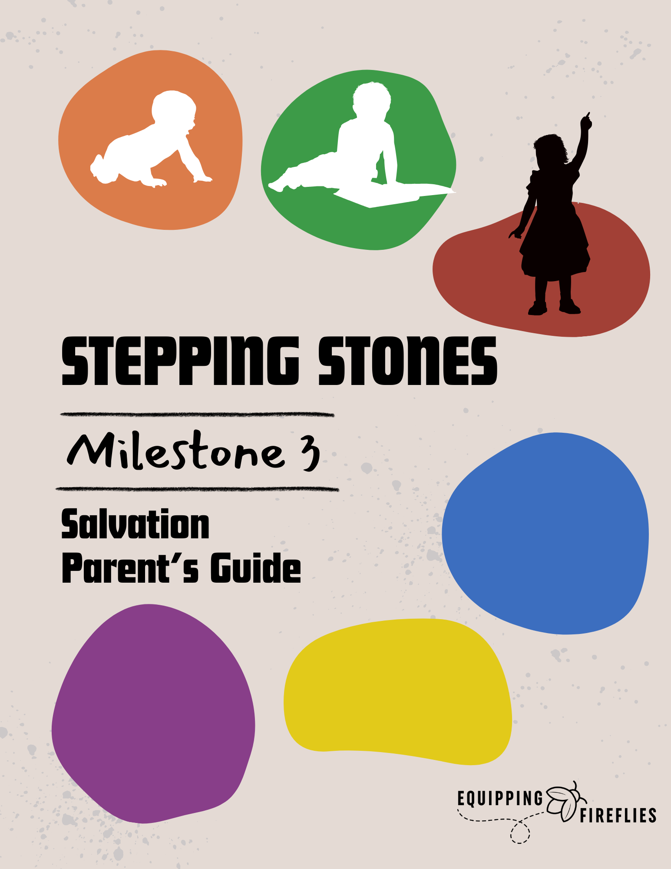

Salvation

Stepping Stone Class

Significant moments, “rites of passage,” or “milestones” are important times in our children's lives. Milestones mark and celebrate life-changing moments in a family’s spiritual journey. Yet, we often commemorate such occasions with a passing “congratulations” or skip over them together.

Key times include baby dedications, receiving their first Bible, salvation, baptism, communion, and transitions to new school grades. Milestones can be **stepping stones** for children as they mark special occasions in their young lives.

**SALVATION** is the third in the Stepping Stone series developed to help you to teach and celebrate with the children.

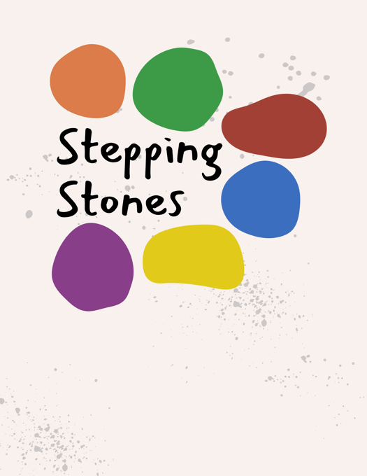

The six STEPPING STONES include:

1. Parent/Child Dedication
2. Bible Presentation
3. Salvation
4. Baptism
5. Communion
6. Graduation

We are excited that you have decided to take advantage of these special moments and will be praying for you as you lead your children to know Him.

Janine McNally, ThM. D. Min.

Equipping Fireflies

Salvation

Stepping Stone Class

Dear Parent/s

Thank you for attending this class with your student. Our goal is to encourage both you and your child as they take this step for the first time.

As we progress through the material, please help your child follow along in their student guide and fill in the blanks when appropriate.

Throughout the class, we will also have Group Discussions. This will be a time when we will break into small groups, and you can talk with your child about the material.

The questions and answers are included below.

Group Discussion #1



**Break into small groups and talk about the following questions.**

**Illustration** (Parents Read):



Suppose you are in a hospital dying of cancer.

I come to visit and say, “Let’s take the cancer cells from your body and put them into my body.”

**Question**:

If that were possible, what would happen to me? [I would die].

**Question**:

What would happen to you? [You would live].

I would die in your place. I would die instead of you.

The Bible says that Jesus took our place. He paid the penalty we deserved (because of our sin), placed it on Himself, and died in our place. He paid our sin penalty.

Three days later, Jesus came back to life to prove that sin and death had been beaten and that His claims to be God were true. He has provided a way for us to be with Him forever. That is good news!

**Join back in with the whole group and share your answers.**

Group Discussion #2



**Question**:

Is it a gift if you have to pay for it? [No].



Jesus gave His life for you. He died a horrible, painful death on a cross.

**Question**:

How much do you think that is worth?

**Question**:

Can you work your way to heaven by doing good things?

* Going to Church?
* Being kind to a sibling?
* Telling the truth?

How do we know that we will go to heaven when we die? [Because God promised].

Letter to Parents

If your child has believed, we are excited! You can write their name and the date on their Faith Certificate to remind them of their trust in Jesus.

If they are still not sure, talk about it together. Ask your child to tell you when they believe.

As your child learns more about God and grows in their relationship with Him, it is

completely normal for them to need assurance of their salvation.

We encourage you to talk with your child and remind them that they do not need to keep asking Jesus to be their Savior. Remind them that NOTHING can separate us from Him.

*“I give them eternal life, and they will never die. No one will steal them out of my hand. My Father, who has given them to me, is greater than anyone.*

*No one can steal them out of my Father’s hand.”*

John 10:28-29 (NIV).

*“Nothing at all can ever separate us from God’s love.*

*That’s because of what Christ Jesus our Lord has done.”*

Romans 9:39 (NIV).

You can be 100% sure that God will keep His promise.

Once you have believed, YOU ARE SAVED FOREVER!

Most parents want to do the right thing, but they are often either too busy or overwhelmed.

You need to be a good role model to set an example for your children.

They are watching.

**These are just some suggestions to get you started.**

* Make sure your children have a Bible of their own. See the **Bible Recommendations** page for suggestions.
* Make sure it’s age-appropriate. They can’t read it if they don’t understand it.
* Guide them – Take a few minutes each day to read and pray with them. Help them begin a Quiet Time Journal, recording what they learn.
* Make time each day to read YOUR Bible. Kids learn by what they see you do.



The Gospel

Bad News

**1. We Have All Sinned.**

*"For all have sinned and fall short of the glory of God."* Romans 3:23 [NIV].

**2. Sin Results in Death.**

*"For the WAGES of sin is death, but the gift of God is eternal life, through Jesus Christ our Lord."* Romans 6:23 [NIV].

Good News

**1. Jesus Died for Us.**

*"But God demonstrates His own love for us in this: While we were still sinners, Christ died for us."* Romans 5:8 [NIV].

**2﻿. Do you Believe This?**

"*For God so loved the world that He gave His only Son,* *that whoever BELIEVES in Him will not perish, but have eternal life*." John 3:16 [NIV].

“Understanding Life” Series for Kids

Available now on Amazon!

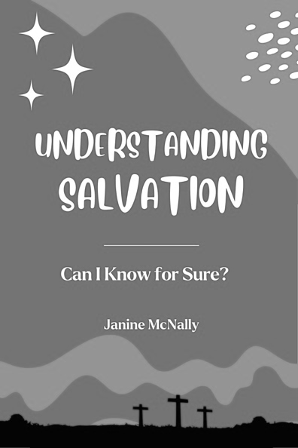**UNDERSTANDING SALVATION** is designed for children ages 7-12 to use independently or with a parent.

It presents the good news of Jesus in a clear and easy-to-understand way that will help them know FOR SURE that they will live with Jesus in heaven one day.

Children will learn the key principles of salvation, teaching the "Bad News" (sin) and "Good News" (Jesus), along with Bible verses and simple illustrations. This 60-page book will help them deepen their understanding of God's grace and begin their relationship with Him.

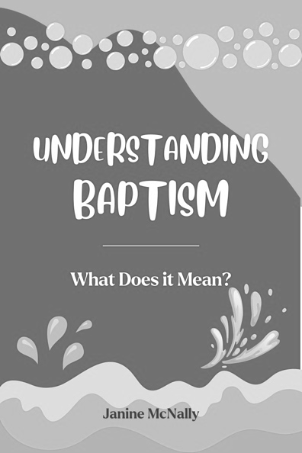**UNDERSTANDING BAPTISM** is a 56-page workbook designed for children ages 7-12 to use independently or with a parent or leader.

This book answers these questions.

• How can we be saved?

• Can I be sure l am saved?

• What is baptism?

• Why should I be baptized?

• When should I be baptized?

• What happens during a baptism?

It is intended for those who have already expressed their belief in Jesus for salvation and have asked about being baptized.

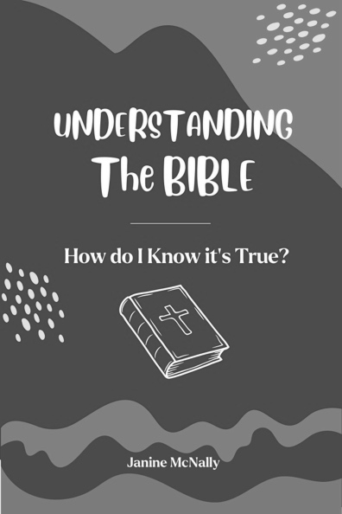**UNDERSTANDING the BIBLE** is the third book in the “Understanding Life” series for kids.

When your child asks the tough questions, do you have answers?

* How do we know the Bible is true?
* Is the Bible trustworthy?
* How do we know that it is really God’s Word?

Written for children ages 8-12, this 70-page book teaches basic Bible apologetics and defines the terms Inspiration, Inerrancy, and Preservation. It also talks about the Bible’s structure, how to have a Quiet Time, and how to memorize God’s Word.

**UNDERSTANDING GOD** answers the questions that children ask daily about God, the Bible, salvation, life, death, the afterlife, angels, demons, and more. This 94-page book answers:

1. What is God like?

2. How did He create the World?

3. Who Created God?

4. Who is the Holy Spirit?

5. How can Jesus be God but also be God's Son?

6. Why does God let bad things happen?

7. Can God make mistakes?

8. Does God Love Me?

We need to be prepared with answers, or they will look elsewhere.

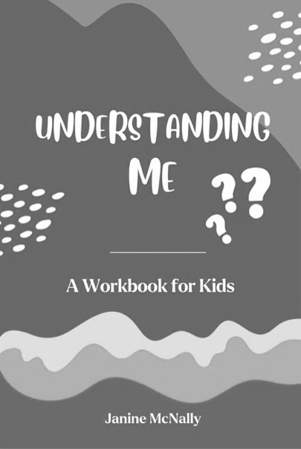**UNDERSTANDING ME** addresses the big question, “Who am I?” in this 85-page book for kids ages 9-12.

Our world says, “There’s no right or wrong,” “We decide what is true and right,” and “We can create our own identity.” At a time when kids are going through enormous changes, they are confronted with ambiguity and confusion.

1. Who am I?

2. Am I loved?

3. Am I alone?

4. Why am I here?

Each question is handled from a Biblical perspective and ends with the hope of a new life, a new body, and a new world for those who have trusted in Jesus.

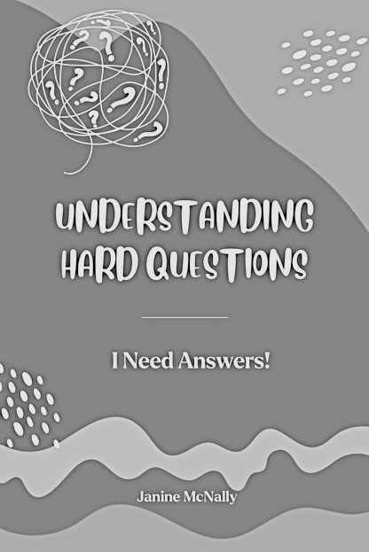

**UNDERSTANDING HARD QUESTIONS** answers 56 of the most common questions kids ask from a Biblical perspective and age-appropriate way. Some of the questions include?

* Who created God?
* ﻿﻿Does God speak to people?
* ﻿﻿Will God stop loving me if I keep sinning?
* ﻿﻿How did Jesus perform miracles?
* ﻿﻿Why do people get sick and die?
* ﻿﻿Why did my parents get divorced?
* ﻿﻿Can Christians lose their salvation?
* ﻿﻿How can God forgive murderers?
* ﻿﻿Why is sex outside of marriage wrong?
* ﻿﻿Are there more than two genders?
* ﻿﻿Can I be sure that I will go to heaven?

Kids are asking questions and need good answers from reliable sources.

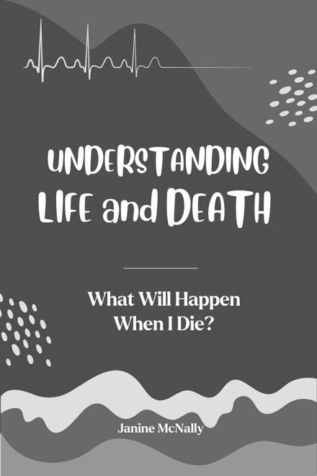**UNDERSTANDING LIFE & DEATH** is written for children ages 8-12 and addresses the questions that arise when a child experiences the death of a loved one.

* Why Do People Get Sick and Die?
* What Happens After You Die?
* If God Loves Me, Why Did My Dad Die?
* What is Heaven Like?
* Will Everyone Go to Heaven No Matter What They Believe?
* Do People Who Never Hear About Jesus Go to Heaven?
* Is Hell Real?
* How Could a Loving God Send People to Hell?
* Why Did God Create Satan?

These questions and more in this 104-page are answered from a Biblical perspective in an age-appropriate way to provide help and hope in a time of sadness and grief.