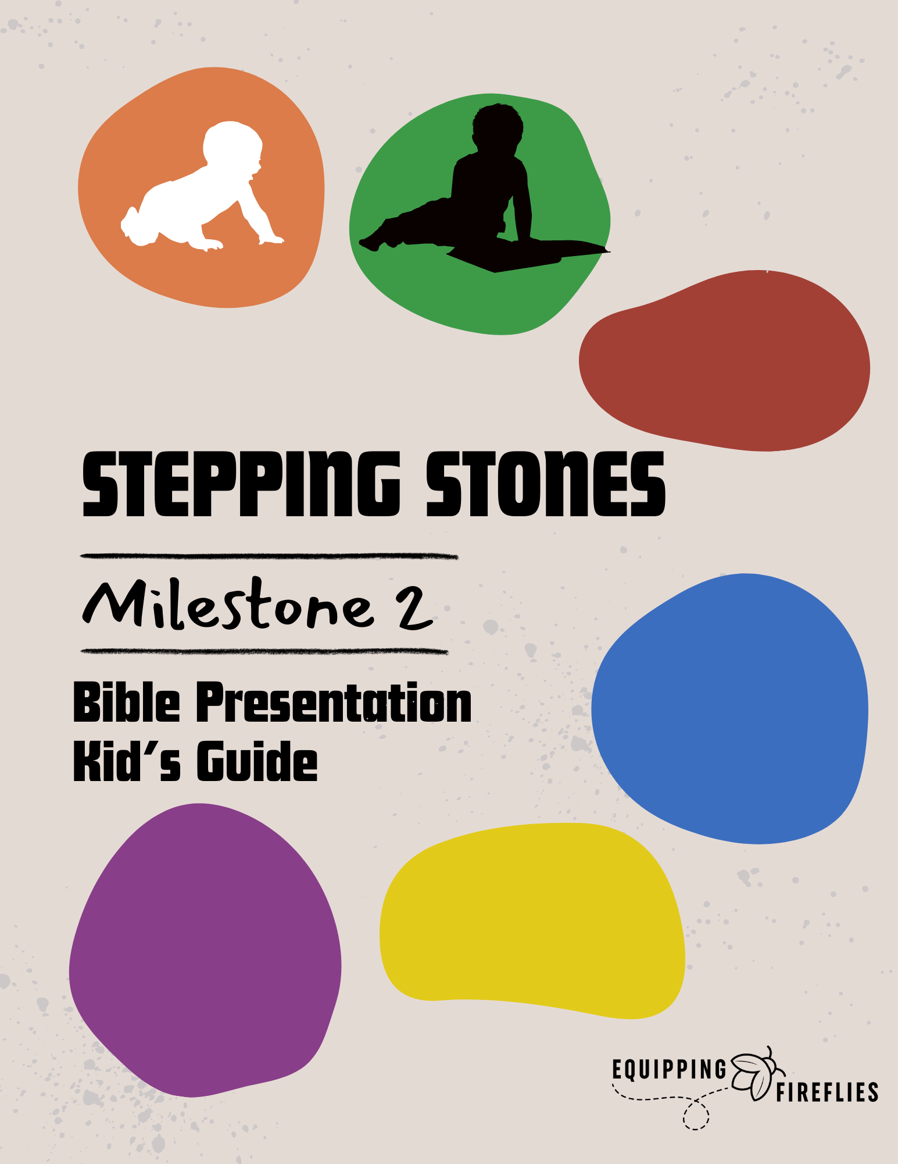

Salvation

Hey, welcome to our Salvation Class. We’re so excited that you’re here!

Icebreaker

SHARE: Your name (if you have a large class).

SHARE: What is your favorite ice cream flavor?

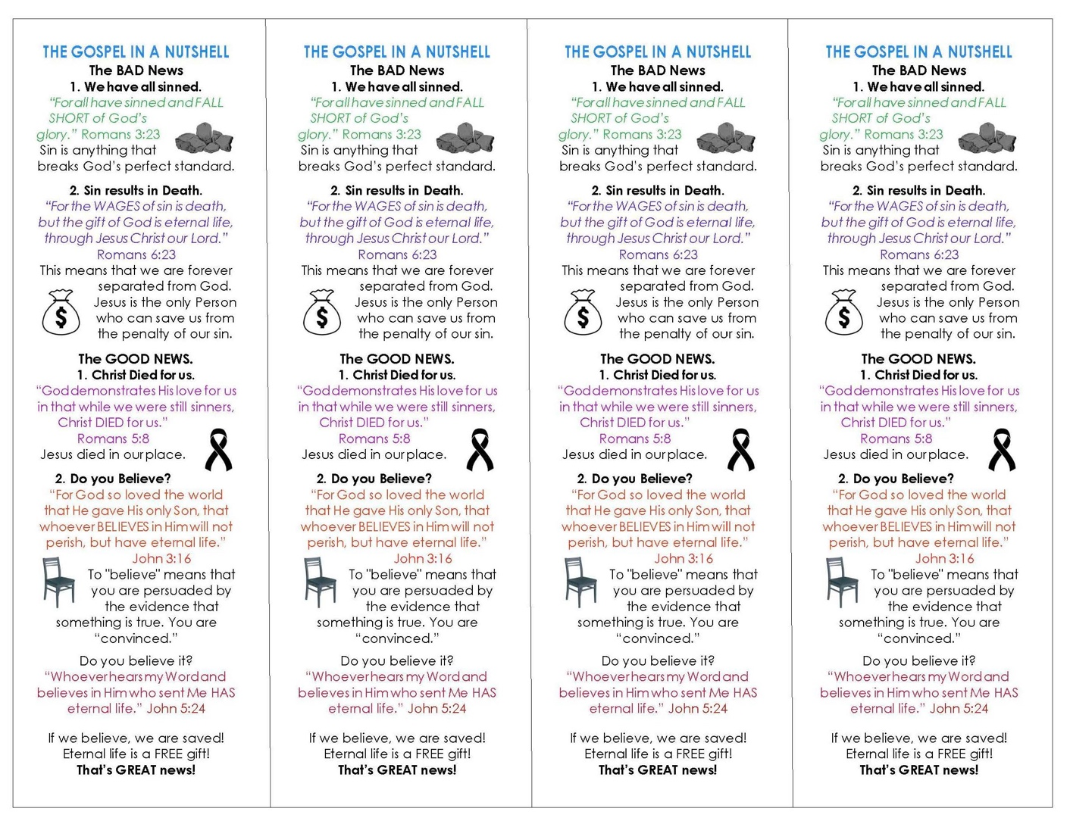



The Gospel

Have you ever wondered how to get to heaven?

The Bible tells us what is required, and that’s what we will talk about today.

Take a look at your bookmark.

Bad News

First, I need to tell you some bad news.

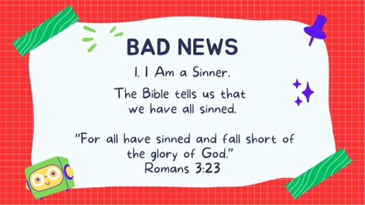1. I Am a Sinner.

The Bible tells us that we have all sinned.

*“For all have sinned and fall short of the glory of God.”*

Romans 3:23.

Question: What is “sin?”

____________________________________________________________________________________________________________________

“Sin” means “to miss the mark.” Whenever we lie, hate, lust, gossip, or do anything wrong, we miss God's standard.

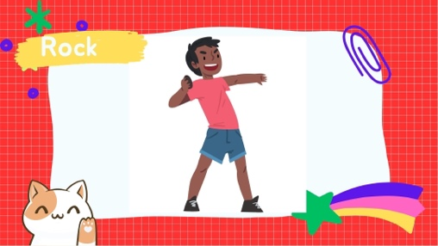

Suppose you and I were each to throw a rock as far as possible to try to hit the North Pole. You might throw farther than me, but neither of us would reach the goal. It’s impossible.

**Question**: What does it mean when it says that we “fall short”?

____________________________________________________________________________________________________________________

When the Bible says, *“All have sinned and fall short,”* it means that we have all come short of God’s standard of perfection. We have not been perfect in our thoughts, words, and actions.

**Questions**:

Have you ever done anything wrong? (Circle One) YES NO NOT SURE

Are you a sinner? (Circle One) YES NO NOT SURE

What kinds of sins have you done?

____________________________________________________________________________________________________________________

Imagine if you sinned one time each day; how many sins would that be in a year?

(Circle One) 5 10 20 52 365

That’s a lot of sins! Let’s keep reading.

2. The Penalty for Sin Is Death.

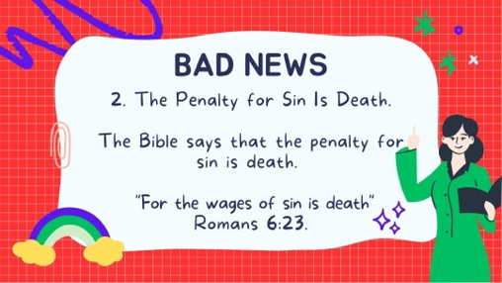

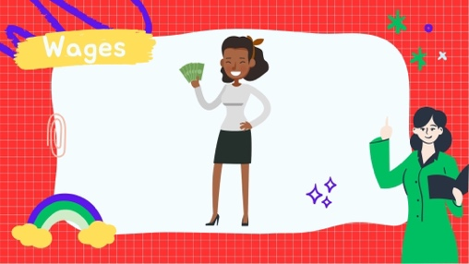**Question**: What is a “wage”?

____________________________________________________________________________________________________________

A wage is a payment for what we EARN!

Suppose you worked for me, and I paid you $50. That $50 was your wages—that’s what you earned. The Bible says that by sinning, we have earned death. That means we deserve to die and be separated from God forever.

Death is another way of saying that we are separated from God.

God is Holy (Perfect), so our sin separates us from Him.

That’s bad news!

Good News

Thankfully, there is also some good news.

Since there was no way that we could get to God, the Bible says that God came to us!

1. Jesus Died to Pay My Penalty.

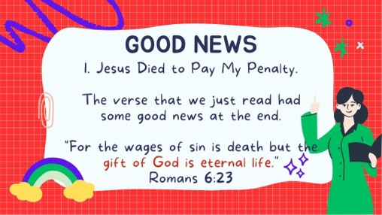

**Question**: What is the good news?

____________________________________________________________________________________________________________________

But how do we get this gift if we are sinners?

The Bible says:

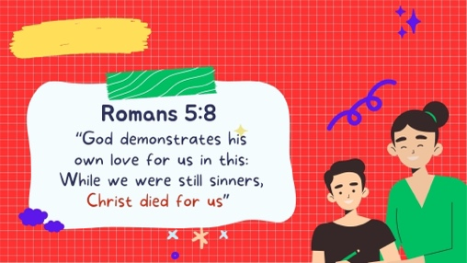

Since the penalty for sin is death, whenever sin is present, someone must die and pay the penalty of “death.” That means we would spend forever separated from God. This verse tells us that someone else died for us.

Group Discussion #1

**Illustration** (Parents Read):

Suppose you are in a hospital dying of cancer.

I come to visit and say, “Let’s take the cancer cells from your body and put them into my body.”

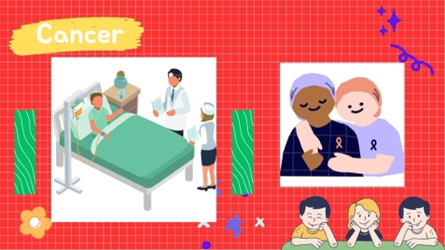

**Questions**:

If that were possible, what would happen to me?

____________________________________________________________________________________________________________________

What would happen to you?

____________________________________________________________________________________________________________________

I would die in your place. I would die instead of you.

The Bible says that Jesus took our place. He paid the penalty we deserved (because of our sin), placed it on Himself, and died in our place. He paid our sin penalty.

Three days later, Jesus came back to life to prove that sin and death had been beaten and that His claims to be God were true. He has provided a way for us to be with Him forever. That is good news!

**Join back in with the whole group and share your answers.**

Good News

2. I Can Be Saved Through Faith.

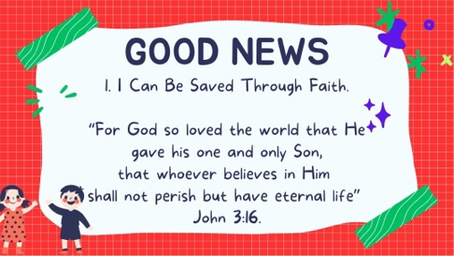

****The Bible tells us that whoever BELIEVES in Jesus will be saved. Faith is another word for “trust” or “belief.”

People sometimes are confused by what it means to believe.

What is the object in this picture?

_____________________________________

Believing is just believing.

If you believe it is a pen, you don’t need to believe “harder” or do something extra to help you believe.

If you are convinced that it is a pen, then you believe.

Just as you trust (or believe) that a chair will hold you up, through no effort of your own, when you sit on it, so you must trust Jesus Christ to get you to heaven through no effort of your own. Trying to work our way to heaven is not possible.



Remember that God’s standard is PERFECTION. Since we could not reach that standard, we needed a different way.

We must believe that when Jesus died on the cross for our sins, He paid our FULL sin penalty. 100% of the cost. He doesn’t want our good works. Going to church won’t help pay the cost. The penalty is death, and the only way to pay the penalty is by dying. Jesus did that for us.



Trying to pay for a gift means that it’s not a gift.

In fact, they would feel insulted if you tried to pay for it because it was intended to be a GIFT.

We can’t pay the penalty with good works. Read this verse together:

# 

The Bible says that our FAITH is accepted, even though they DO NOT WORK.

We cannot work our way to heaven. We must trust in Jesus Christ ALONE, and God will give US eternal life as a FREE gift! It is no longer a gift if we try to pay for it.

Group Discussion #2

**Question**:

Is it a gift if you have to pay for it? (Circle One) YES NO NOT SURE

Jesus gave His life for you. He died a horrible, painful death on a cross.

How much do you think that is worth?

____________________________________________________________________________________________________________________

**Question**:

Can you work your way to heaven by doing good things?

* Going to Church?
* Being kind to a sibling?
* Telling the truth?

(Circle One) YES NO NOT SURE

How do we know that we will go to heaven when we die?

____________________________________________________________________________________________________________________

Session Two

How To Be Sure

Review

**Questions**

Why do we need Jesus? (Circle the right answer).

1. We don’t – we’re already good enough.
2. Because we are sinners and we are separated from God

Why did Jesus die on the cross? Circle the right answer).

1. Because He was a nice person.
2. Because He wanted to pay our sin penalty so that we could go to heaven one day.

What happens when you trust in Jesus to save you?

1. We are probably saved, but we still need to do good works to make sure.
2. Our sins are FULLY forgiven, we receive eternal life, and we will live with God forever in heaven.

Do you believe that Jesus died for you and paid for all of your sins?

(Circle One) YES NO NOT SURE

Praying a special prayer doesn’t save you any more than attending church or being a good person. Praying is just talking to God. But some people like to tell God about their belief in Jesus, and they might pray something like this.

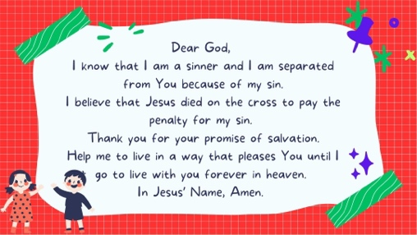

If you trust the promise of salvation in Christ, then you can know for sure that God is your Father, and you are his child.

That’s a promise of absolutely free grace. There is nothing in that promise about what you’re supposed to do. It’s all about what Christ did in history to save sinners.

Being Sure of Your Salvation

If you are born into a family, can you be “unborn?”

(Circle One) YES NO NOT SURE

If you hit your sister, does that mean you are no longer part of the family?

(Circle One) YES NO NOT SURE

If your parents are furious at you, does that mean they are no longer your parents?

(Circle One) YES NO NOT SURE

Can you stop being a “son” or “daughter” in your family?

(Circle One) YES NO NOT SURE

When you trust in Jesus for salvation, you become a part of God’s family.

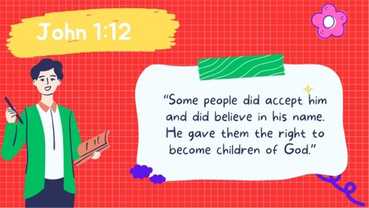

You become a child of God.

You have become a part of God’s FOREVER family.

You can NEVER be unborn!

Assurance Poster



Hold the promises of God tightly in your hand - make a fist and remember that He is always with you.

Believe

The thumb is the most important, able to hold everything together. After we believe in Jesus for eternal life, we need to continue to BELIEVE His promises.

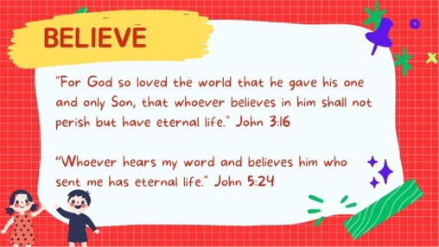

Listen

The index finger points to emphasize instructions. We need to LISTEN to the prompting of the Holy Spirit. He lives within us and will help us.

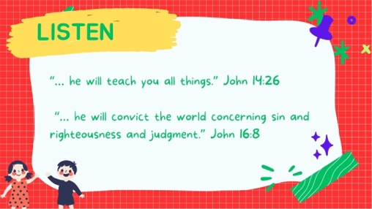

The Bible tells us that the Holy Spirit will teach us, convict us of sin, help us, and remind us that we are saved.

Confess

The third finger is the biggest and strongest of the fingers. Sin separates us from God the same way that it does with a person. Forgiveness is always available if we confess.

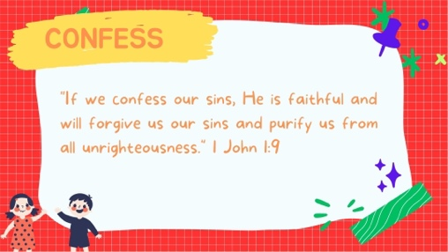

All of us still do things that separate us from God. It saddens God when we do, say, or think wrong things. But the Bible tells us that we can tell Him (confess) those things, and He promises to forgive us.

The word confess means to tell what you did. To “agree” with God that what you did was wrong.

Whenever you realize you have sinned, just tell God about it (Admit you were wrong), and He forgives you.

In fact, the Bible says...

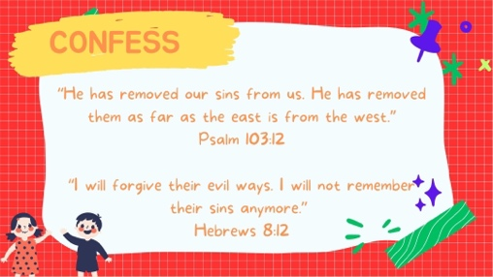

How far is the East from the West?

____________________________________________________________________________________________________________________

God tells us that He chooses to forget our sins.

Learn

The fourth finger supports the other fingers. Reading the Bible will strengthen our faith, transform our thinking and change us to become more like Jesus.

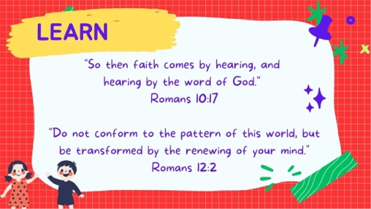

Serve

The pinkie is often forgotten and taken for granted. Make sure you meet regularly with Christian friends and find a place to serve in the church to help you grow.

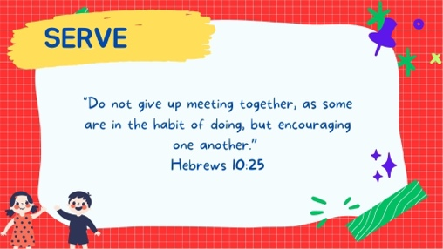

Hold the promises of God tightly in your hand! When you have doubts, ALWAYS look to Jesus!